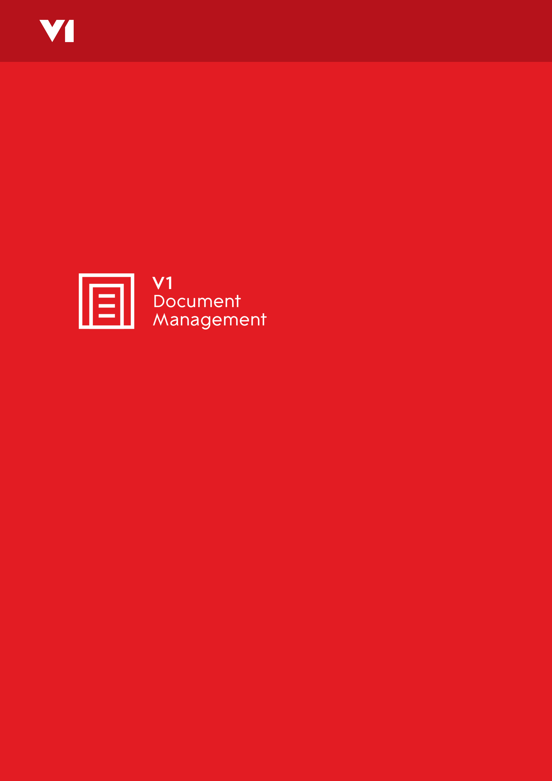

Technical Detail Information Request

Invoice Automation for Sage 200
21 August 2018
Technical Detail Information Request

Background
The Purchase Invoice Automation solution for Sage 200 from V1 employs an n-tier client-server architecture across one or more Windows-based servers. The solution can be deployed ‘on premise’ or hosted by a third-party in a ‘Private Cloud’ configuration with or separate to the Sage 200 system itself.

For end-users with very low volumes of invoices (generally less than 10,000 invoices per annum) and a very small number of users involved in approvals (fewer than 10), the whole solution may be deployed on the same Windows Server as the Sage 200 system itself. Note that running Sage 200, SQL Server and the V1 services on a the same server can adversely affect the performance of Sage 200 at certain times, such as immediately after scanning a large batch of paper invoices.

In most cases the V1 applications will run on a separate dedicated server. At present, Windows Server 2008 R2 and later are supported. The V1 applications require a Microsoft SQL Server. This can be the same SQL Server used by Sage 200 itself, but it does not have to be. It can be on the V1 server, the Sage server or a separate server / cluster. Note that V1 does not normally supply SQL Server licences or CALs. When sharing a SQL Server, the number of CALs required is normally the higher of the number of Sage users and the number of V1 users, but please consult your Microsoft provider for licencing advice.

The V1 solution will normally also need access to an email server supporting SMTP and POP3. This does not necessarily need to be the end-users primary email server.

The normal environment for a Sage 200 solution consists of a single Sage 200 server/environment known as ‘LIVE’. This single server will normally support both live and test databases. If a completely separate Sage environment needs to be supported, eg for Disaster Recovery purposes or for testing a new release of Sage 200, please advise V1 and your Sage provider as this is not provided for by default in this ‘standard’ solution.

This document is used to gather the technical details before installation begins and the completed document will be included as an Appendix to the Solution Design document.

Sage 200 Details

Sage 200 version | (TBC)
Sage support partner | (TBC)
Account Manager | (TBC)
AM Contact Details | (TBC)
Project Manager | (TBC)
PM Contact Details | (TBC)
IT Manager | (TBC)
IT Contact Details | (TBC)

Required Information and Checklist for Sage 200 integration

In this document, ‘server’ can refer to either a physical server or a virtual server hosted in a VMWare or similar environment.

V1 Application Server | Notes
Server Name/IP address for LIVE V1 Server | (TBC) | Can be for all V1 products but will normally be a dedicated server
Virtual / Physical Server | (TBC)
Server Name/IP address for TEST V1 Server | N/A | Not implemented as standard, but may be required to test a new version of Sage 200 in parallel.
Virtual / Physical Server | N/A
Software Link received and software downloaded to the V1 Application Server | No | Updated version may need to be downloaded onto the server so internet access is needed
Software Server Operating System | (TBC) | For Example:  Windows 2008 R2 64-bit  4GB RAM  C: 20GB D: 8GB
SQL tools, ie sqlcmd.exe and SQL Server Management Studio, installed on the server | (TBC) | SQL Management Tools, with any patches applied, to be able to access the SQL Server databases
Microsoft .NET Framework 3.5.1 installed | (TBC)
Adobe Reader or similar installed on server | (TBC)
Sage 200 client installed on V1 server | (TBC)
Sage user created for V1 | V1System  Passw0rd | V1 will consume one Sage 200 user – can be a web user.
Admin user on the server for install | (TBC) | e.g. Local user called ‘v1admin’ with local admin rights; Password
Service account created on server to run V1 services | (TBC) | e.g. Local user called ‘v1user’ with local admin rights; Password
Service user password set not to expire | (TBC) | Or a process in place to update as needed
Server to be part of the domain the users and other servers are part of | (TBC) | Provide the Domain name
DbWebQuery / WebRetrieve — Web Server (and server details if different to main app server) | (TBC) | IIS (or Apache) will need to be enabled to host the V1 web interface

Server storage meets requirements | (TBC) | Archive database =  [No of documents] x [avg no of pages per document] x 70KB. eg 10,000 invoices per annum with 1.2 pages on average held for seven years will require approximately 6GB. Note that scanning in colour will increase the storage requirements by 4 to 5 times. PDF invoices can be smaller but can also be significantly larger. 150KB per invoice is typical.
Installation drive | (TBC) | e.g. using D:\ - recommendation is not to use the operating system drive
Remote Server Access method | (TBC) | e.g. VPN / RDC / TeamViewer, etc
Server Ports (see below) can be opened | (TBC) | Please confirm the ports below can be used

Server Client Communication Details

Description | Port | Protocol | Where used
Authentication (for all apps and clients) | 32000 | TCP | Between V1 server and all apps and clients
Archive Deposits | 31417 | TCP | Between V1 server and all apps and clients that deposit documents
Archive Queries | 31418 | TCP | Between V1 server and all apps and clients that lookup metadata in the Archive
Web Access | 80*/443 | http/https | Between V1 server and anywhere people are allowed to access the documents
Email sending† | 25 | SMTP | Between V1 server and email server used for sending emails
Fax administration† | 31415 | TCP | Between V1 server and clients monitoring faxes (and/or sending ad hoc faxes)
Fax communications† | 31419 | TCP | Between V1 server and physical machine hosting modem(s)
Data Capture Validation | 31450 | TCP | Between V1 server and Capture client
Data Capture Admin | 31451 | TCP | Between V1 server and Capture client
Data Capture Deposits | 31452 | TCP | Normally only used on the V1 server
Authorise Updates | 31420 | TCP | Between V1 server and Authorise clients
Authorise Queries | 31421 | TCP | Normally only used on the V1 server
Email autoresponder† | 110 | POP3 | Between V1 server and email server where responses and invoices are received
Auditing Service† | 11000 | TCP | Normally only used on the V1 server
UNC Path (file sharing) | 445 | TCP | Between V1 server and shared folders used for automated document deposits

*The port for the web interface can be changed if there are other websites already on the same server. The customer will need to provide the certificate if https is required.
†These components are optional.

In addition to the above, the V1 server will need access to the SQL Server and to the Active Directory.

Database Server Details

Description | Server name
Sage SQL Server | (TBC)
Sage Test Server | N/A
V1 SQL Server | (TBC)
V1 Test Server | N/A

V1 Database Details

Description | Database Name | Login – Password
Live Archive | DbArchive | V1User - Passw0rd
Test Archive | N/A | N/A
Live Data Capture | DbCapture | V1User - Passw0rd
Test Data Capture | N/A | N/A
Live Authorise | DbAuthorise | V1User - Passw0rd
Test Authorise | N/A | N/A

Sage 200 Database Details

Description | SQL Database Name | Login – Password
Sage Config DB | (TBC) | (TBC)
Sage Test Config | N/A | N/A

Workstation Details

PCs | Notes
Client PC operating system | (TBC) | e.g. Windows 7 – 64 bit
Admin username / password | (TBC) | Local admin permissions will be required to install client software.
Number of clients to be used | (TBC) | Administrators only
Microsoft .NET Framework 3.5.1 installed | (TBC)
Remote PC Access method | (TBC) | VPN / WebEx – details

Scanstations | Notes
No of scanstations | (TBC) | Number ordered
Scanstation Operating System | (TBC) | Windows 7 or above
All scanner hardware available. Check sockets on workstations and cables. Most current scanners connect via USB 2.0. Older scanners may require Firewire. SCSI scanners no longer supported by Microsoft. | (TBC) | Kodak scanners recommended
Suitable VRS / AIPE licence available for scanner | (TBC) | Kofax VRS Elite 5.x is recommended. Edition needs to match scanner.
Admin username / password | (TBC) | Local admin permissions are required to install the scanstation software and to amend stored scanner settings.
Microsoft .NET Framework 3.5.1 installed | (TBC)
Scanstation on same network as servers | (TBC)
Scanstation has internet access (for license registration) | (TBC) | Licences already in place
Remote PC Access method | (TBC) | VPN / RDC / TeamViewer

Label Printers | Notes
No of label printers | (TBC) | Optional when using OCR
Printer Make / Model | (TBC) | e.g. Zebra GK420D
Printers are on site (delivered) | (TBC)
Connectivity | (TBC) | Ethernet or USB
Supply of suitable labels available | (TBC)

Email Server | Notes
Email Administrator | (TBC)
Email Admin Contact Details | (TBC)
SMTP Server for outgoing emails and alerts | (TBC)
User Name | (TBC)
Password | (TBC)
Authentication Method | (TBC)
Relaying from V1 server enabled | (TBC)
Admin Email Address | (TBC) | v1admin@domain.com
Default From Address | (TBC) | accounts@domain.com
POP3 Server for email responses and invoices | (TBC)
User Name | (TBC)
Password | (TBC)
Mailbox for Accept | (TBC) | eg approve@
Mailbox for Query | (TBC) | eg hold@
Mailbox for Reject | (TBC) | eg reject@

